**UML CASE DIAGRAM**

1. **eCommerce system**

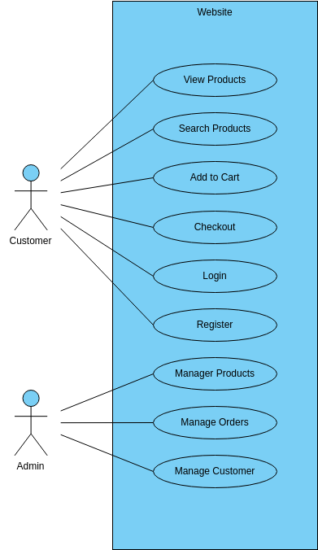

**2)Sports management system**

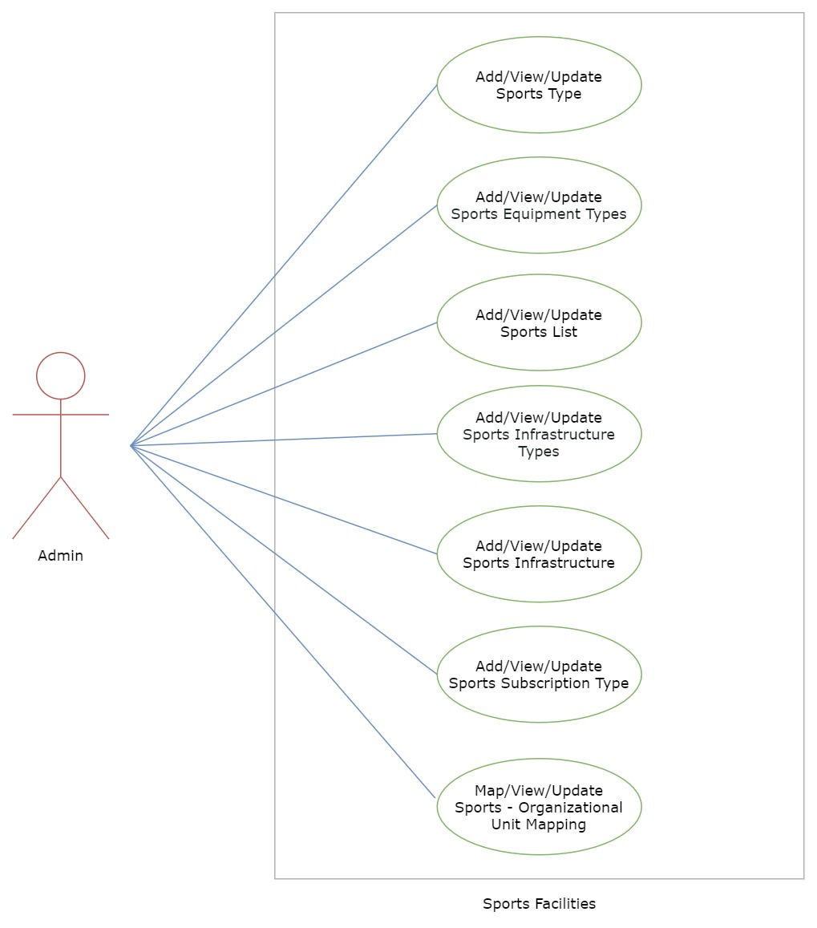

**3)train reservation system**

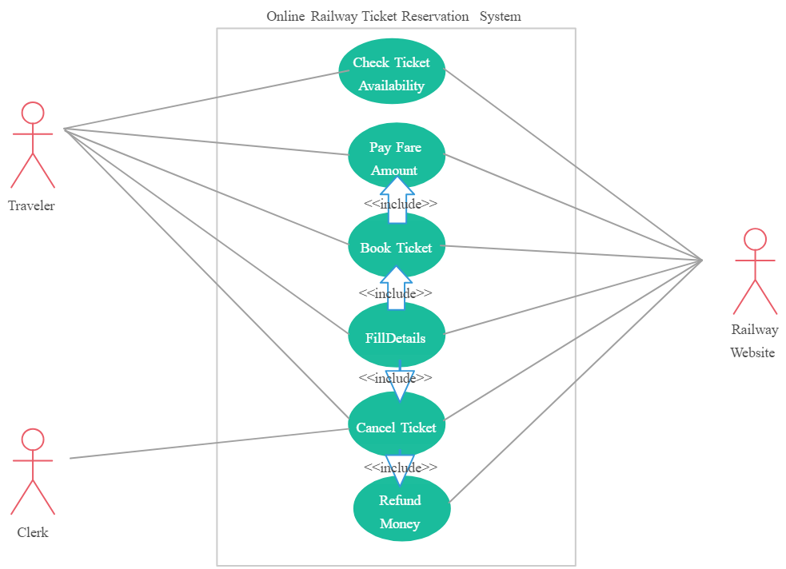

**4)banking management system**

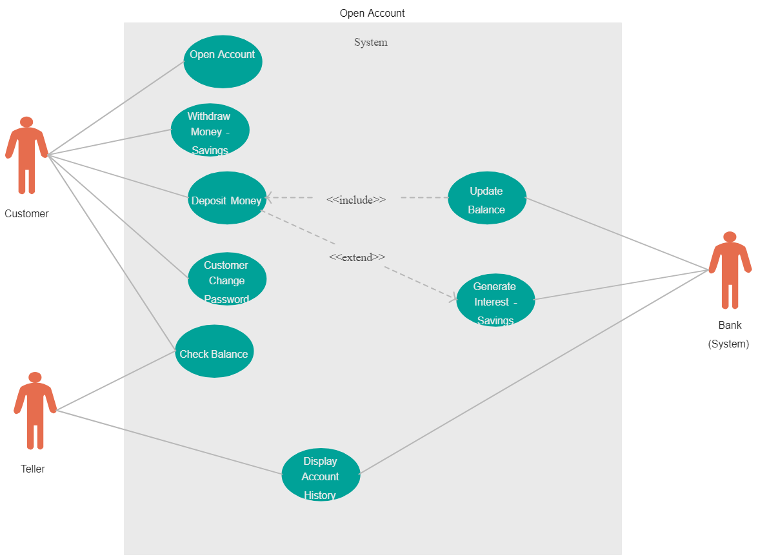

**5)Hotel management system**

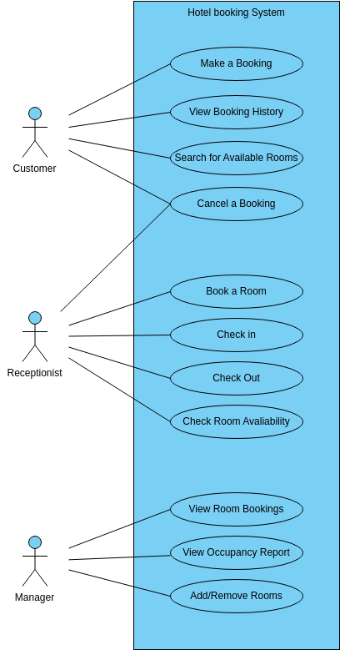

**1)activity diagram for the Hotel management system**

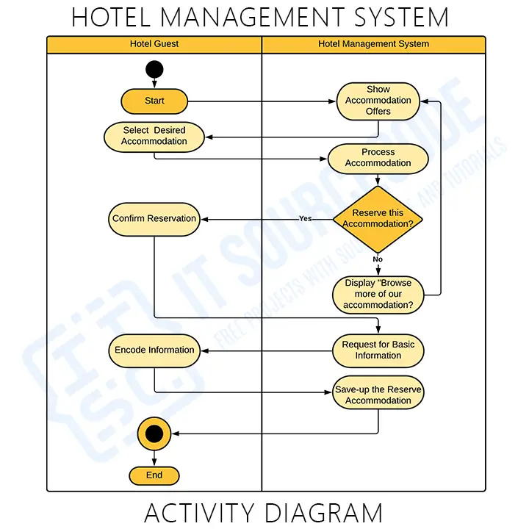

**2)activity diagram for the train reservation system**

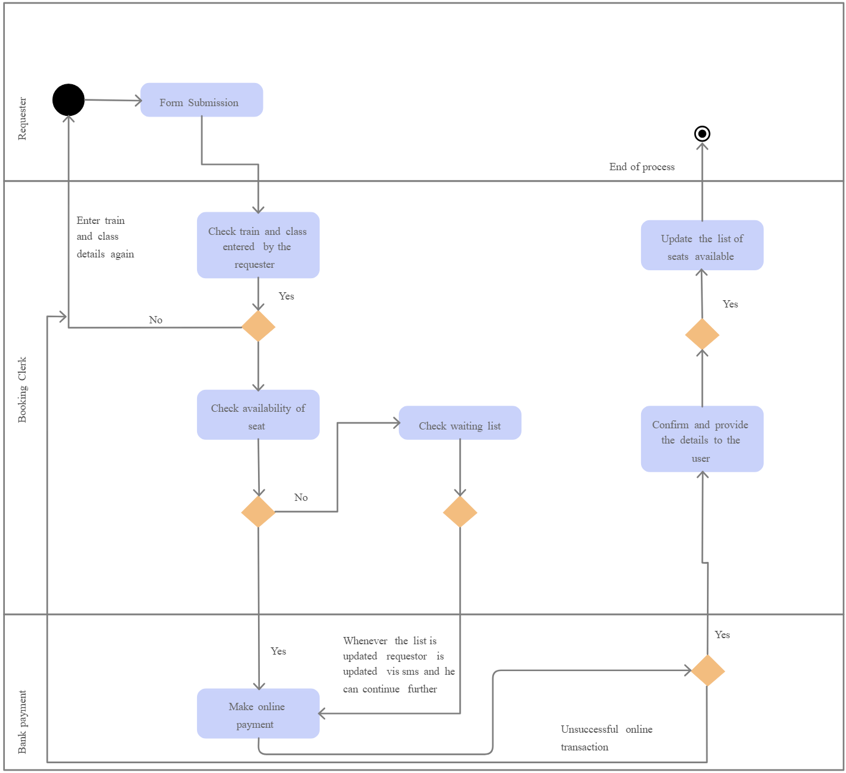

**Activity diagram for the banking system**

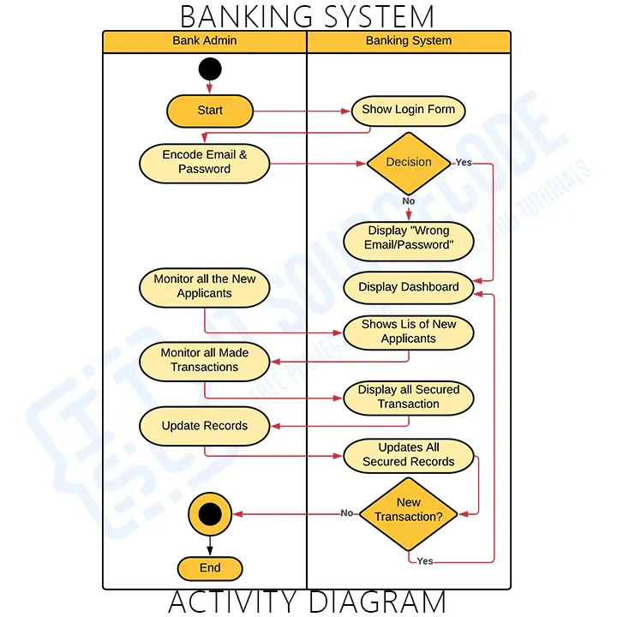

**Activity diagram for the eCommerce**

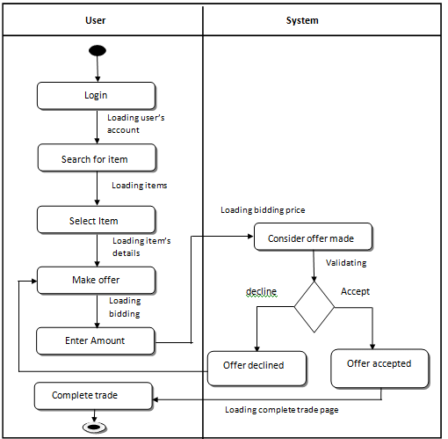

1. **sequence diagram for the eCommerce**

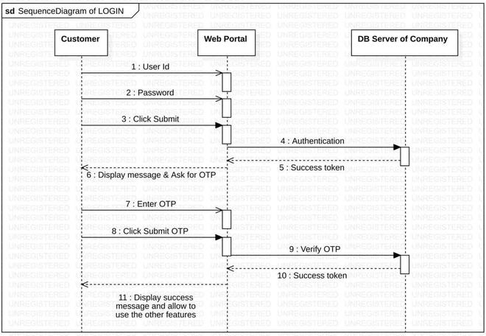

1. **sequence diagram for the sports management system**

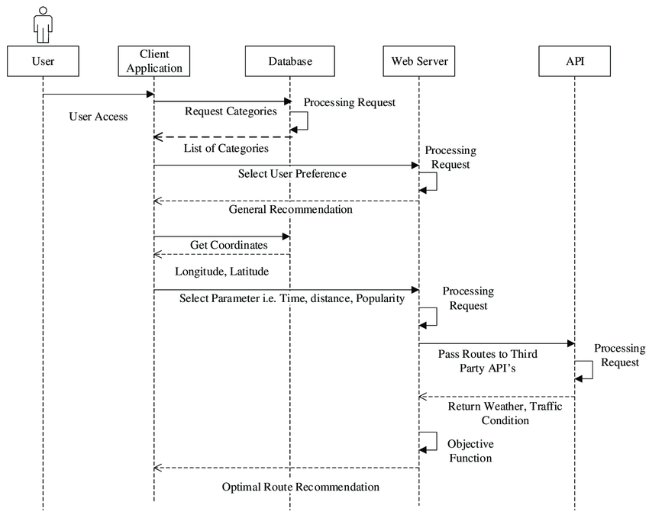

**3) sequence diagram for the train reservation system**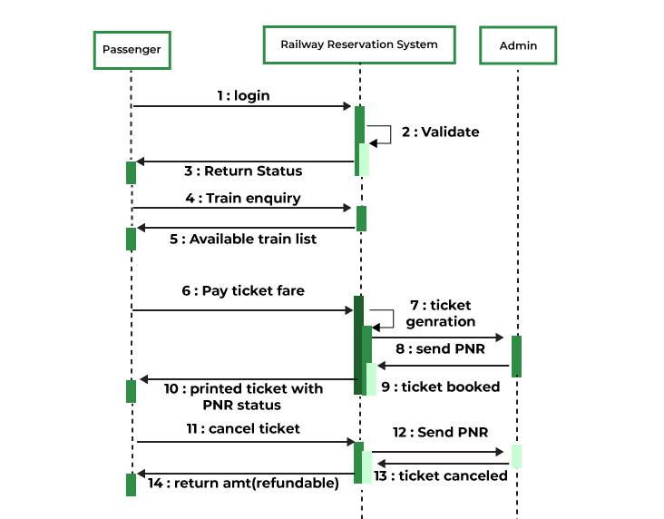

**4) sequence diagram for hotel management system**

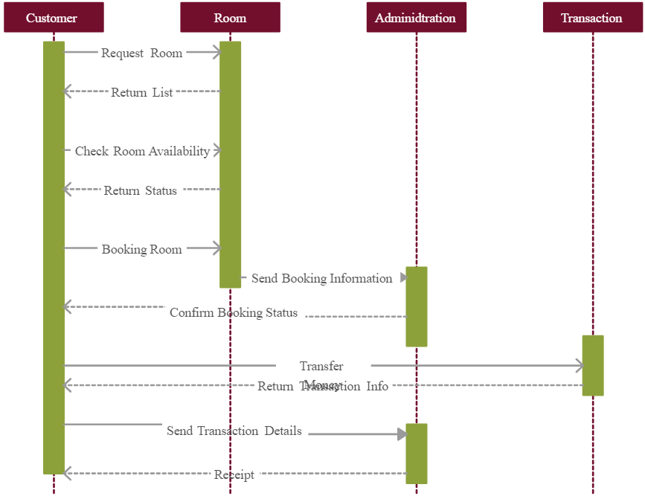

5) sequence diagram for eCommerce system

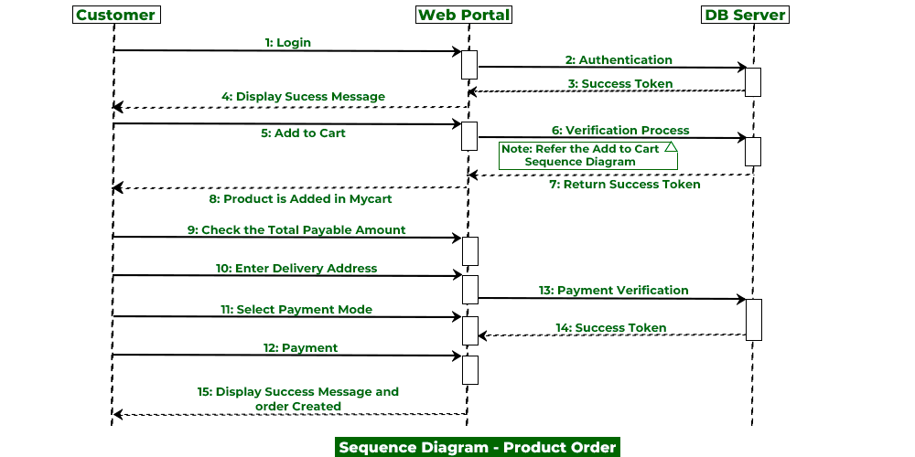

1. **Class diagram for the e-commerce system**

**.**

**.**

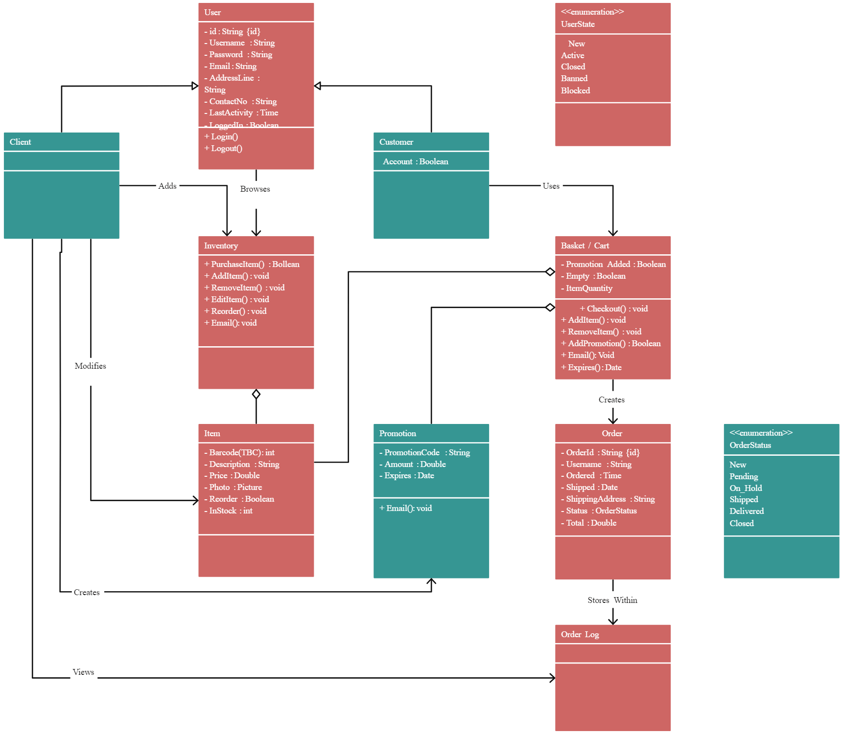

**2) class diagram for the sports management system**